Removing Redundant Messages in Outlook
Please read this entire 3 page document before executing any of these functions to ensure you understand the impact.

Overview
Nothing like coming out of a meeting or being away from work for a couple of days to come back to an Inbox that is overflowing with emails. The Clean Up function in Outlook can help with that as it will remove any redundant or “chained emails”. This occurs when people respond to the same thread, back and forth, until a chain of emails is created. Outlook will not remove any emails where the chain is broken: for example if someone added a document or changed the people on the thread, etc.
There are three main Clean Up processes:
- Clean Up Conversation: The current Conversation is reviewed, and redundant messages are deleted or archived.
- Clean Up Folder: All Conversations in the selected folder are reviewed, and redundant messages are deleted or archived.
- Clean Up Folder & Subfolders: All Conversations in the selected folder and any folder that it contains are reviewed, and redundant messages are deleted or archived.

These functions can be accessed as shown the figure below:
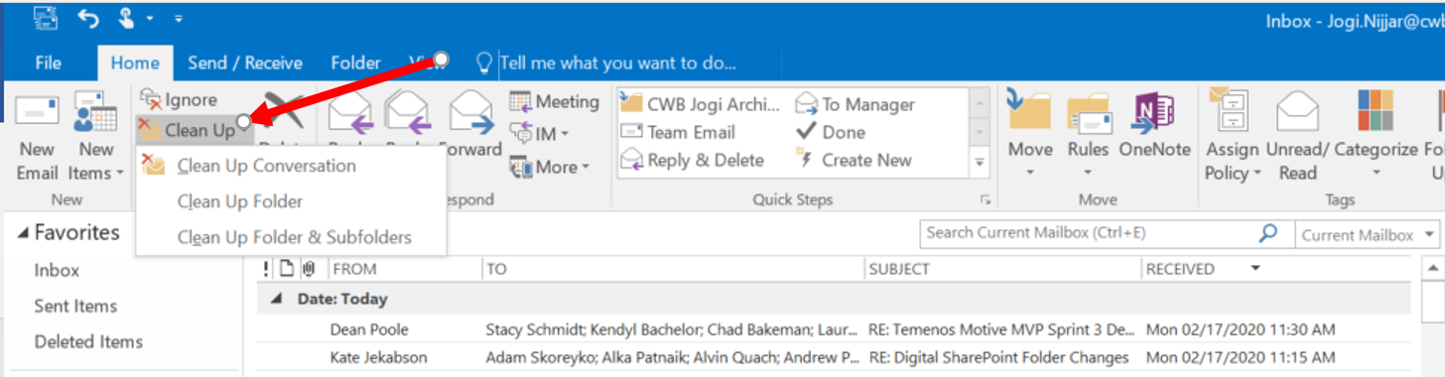

The “Clean Up Folder” can also be found by right clicking the folder in question and bringing up the right-click context menu as shown in the figure below (which appeared when the mouse was hovering over the “Inbox” folder and the mouse was right-clicked):
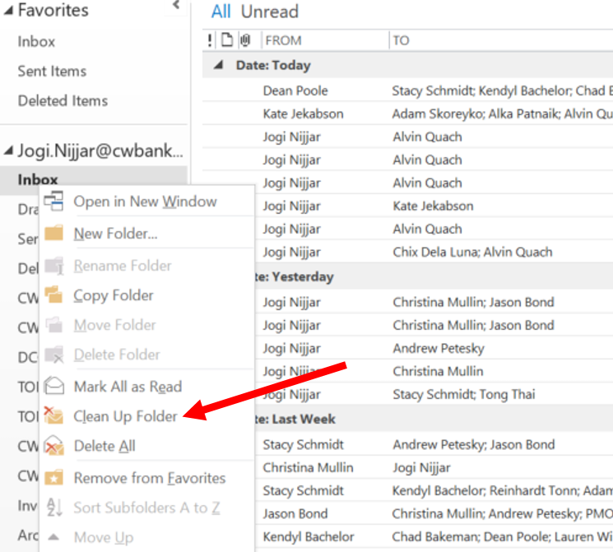
Preconditions.
Before you use any of the functions above, you have to decide if you want to keep all the emails you ever receive (a best practice), or you want to delete redundant copies forever.
If you wish to delete all redundant emails forever, you do not need to do anything. By default Outlook will move the emails identified to your deleted folder. These emails will remain there until you empty your trash folder or a company policy empties your trash folder for you.
If you wish to archive, you need create a folder or choose an existing one. It is assumed users know how to create their own folders under their Inbox in Outlook.
To choose which folder redundant emails go, you need to go to:
Upper left-hand corner of Outlook…FileOptionsClick the Mail TabScroll the middle of the page to the “Cleaned-up items will go to this folder”; Browse to the folder you would like to send redundant emails to. Click Ok Button to save settings change.
Click “File”
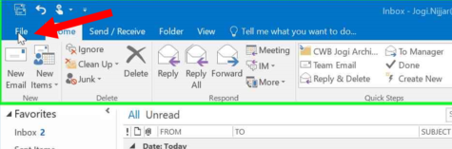
Click “Options”
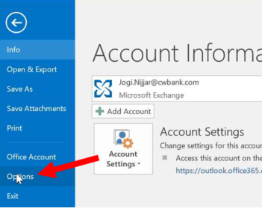

Click “Mail”
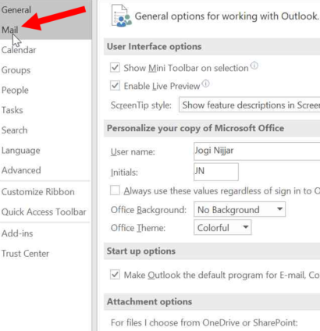
Scroll to the middle of the page to “Cleaned-up items will go to this folder”. Click “Browse” button, select folder you would like redundant emails will go. Click “Ok” button to save your settings change.
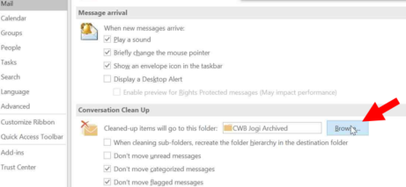

One draw back to this feature is that you will be left with the latest email on a particular thread in most cases. You may remember that a certain person had mentioned something, however, you can’t find it in your Inbox. You will have to go to your folder that has the redundant emails and look there. For people who live in their Inboxes, this is a change in behaviour for them, having to look into another folder for a particular person’s reply. This can be overcome by using the “Search” function in Outlook and retrieve all related emails.

